**In class Exercise – ICE May 2nd, 20219 - Due on or before May 5th**

**Objective:** Two dimensional arrays

|  |
| --- |
| **Important instructions:**   * *All programs must include comments at the top of your program: your name, course name-section number (CSIT 575), program name and the program description in brief.* * *Copy and paste your program code and outputs in Part B of each program.* * *Once it is done, save and submit this word file via Canvas.* |

**1. SumOfDiagonal.cpp**

Write a program that reads a 4-by-4 matrix and display the sum of all its elements on the major diagonal, sub-diagonal (below major diagonal) and super-diagonal (above major diagonal).

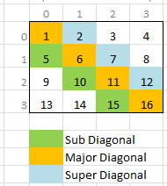

**Sample Output:**

Enter a 4 by 4 matrix row by row:

1 2 3 4

5 6 7 8

9 10 11 12

13 14 15 16

Sum of the elements in the major diagonal is 34

Sum of the elements in the sub-diagonal is 30

Sum of the elements in the super-diagonal is 21

**Given function prototypes**

double sumMajorDiagonal(const double m[][SIZE]);

double sumSubDiagonal(const double m[][SIZE]);

double sumSuperDiagonal(const double m[][SIZE]);

**Copy and paste your program (source) code and the outputs after this line**

**+++++++++++++++++++++++++++++++++++++++++++++++++**